**Web page for students to access all the relative study materials:**

* Selling of notes by students
* Selling of the common stationaries used by students
* Helps students to sort and find the study notes related to the module/subject they are taking (whether is it Polytechnic students/O-Level syllabus/ A-level syllabus/ University course)
* Organisers for students :  
  planners/timetables/to-do list/ calendar of events for the month/ expenditure tracker
* Interactive page where users can ask questions on the forum related to the title of the discussion page
* Games.

Website reference:

For resource:

* display a slide show of the study topic
* have each of the slide show for: O LEVEL SYLLABUS, POLYTECHNIC COURSE, A LEVEL SYLLABUS
* <https://www.loville.co/> for the slide show reference

For main page:

* Taobao <https://world.taobao.com/>
* Nyp website <https://www.nyp.edu.sg/eae/about-eae.html>
* canva <https://www.canva.com/>

For calendar:

* <https://www.webcodegeeks.com/html5/html5-calendar-example/>
* Require : html, css, JQuery

For games:

* spin the wheel <https://wheelofnames.com/>
* flappy bird <https://www.youtube.com/watch?v=VQ4lo6Huylc>

**Main page:**

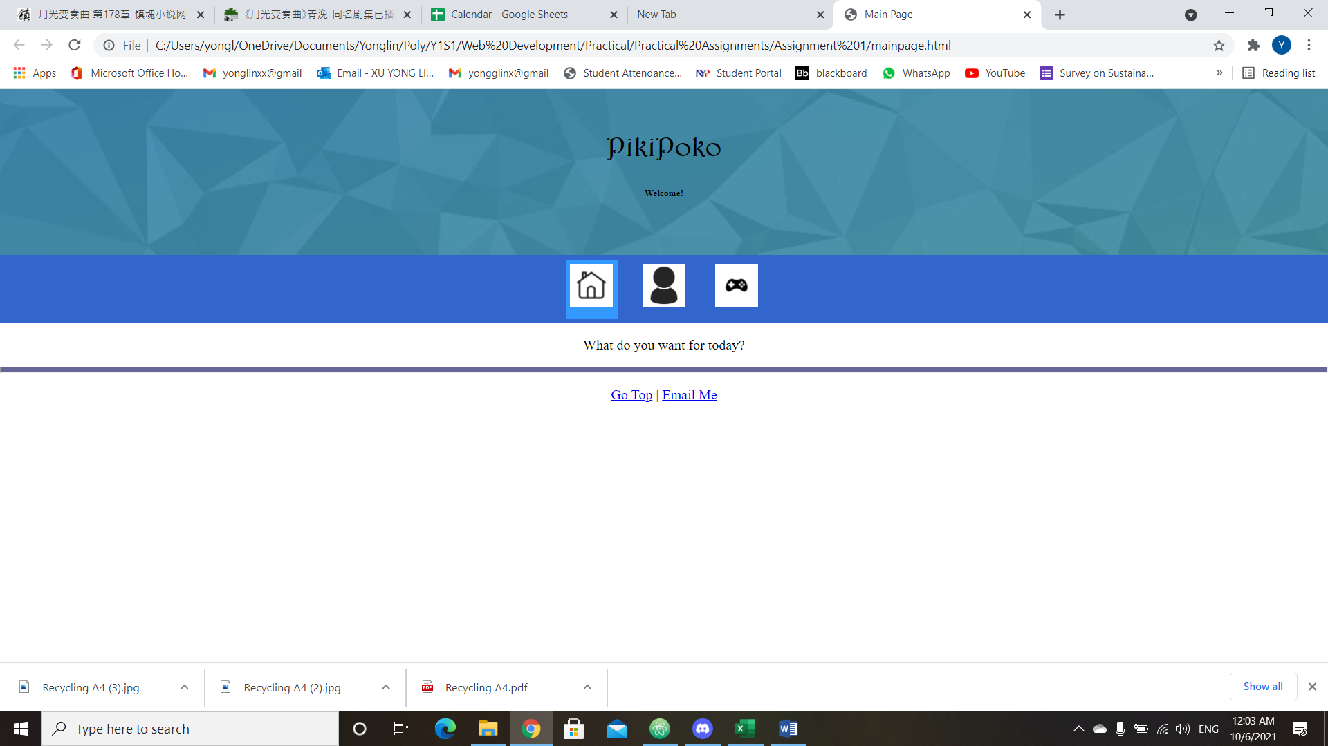

|  |  |  |
| --- | --- | --- |
| Page: |  |  |
| Mainpage | Carousel display image of the products / notes |  |
|  | Navigation bar (at the top) and sticky navigation bar (to navigate around the information of the main page)  Collapse sidebar (to enable users to go to “resources” , “membership signup” , “games”, calendar) | * Applicable to all html folders the nav bar links too. |
|  | Search engine of such products |  |
|  | Display highlight of the month/event (new features or functions etc), update news |  |
|  | External links to educational websites |  |
|  | Link to personal calendar |  |



**Membership page:**

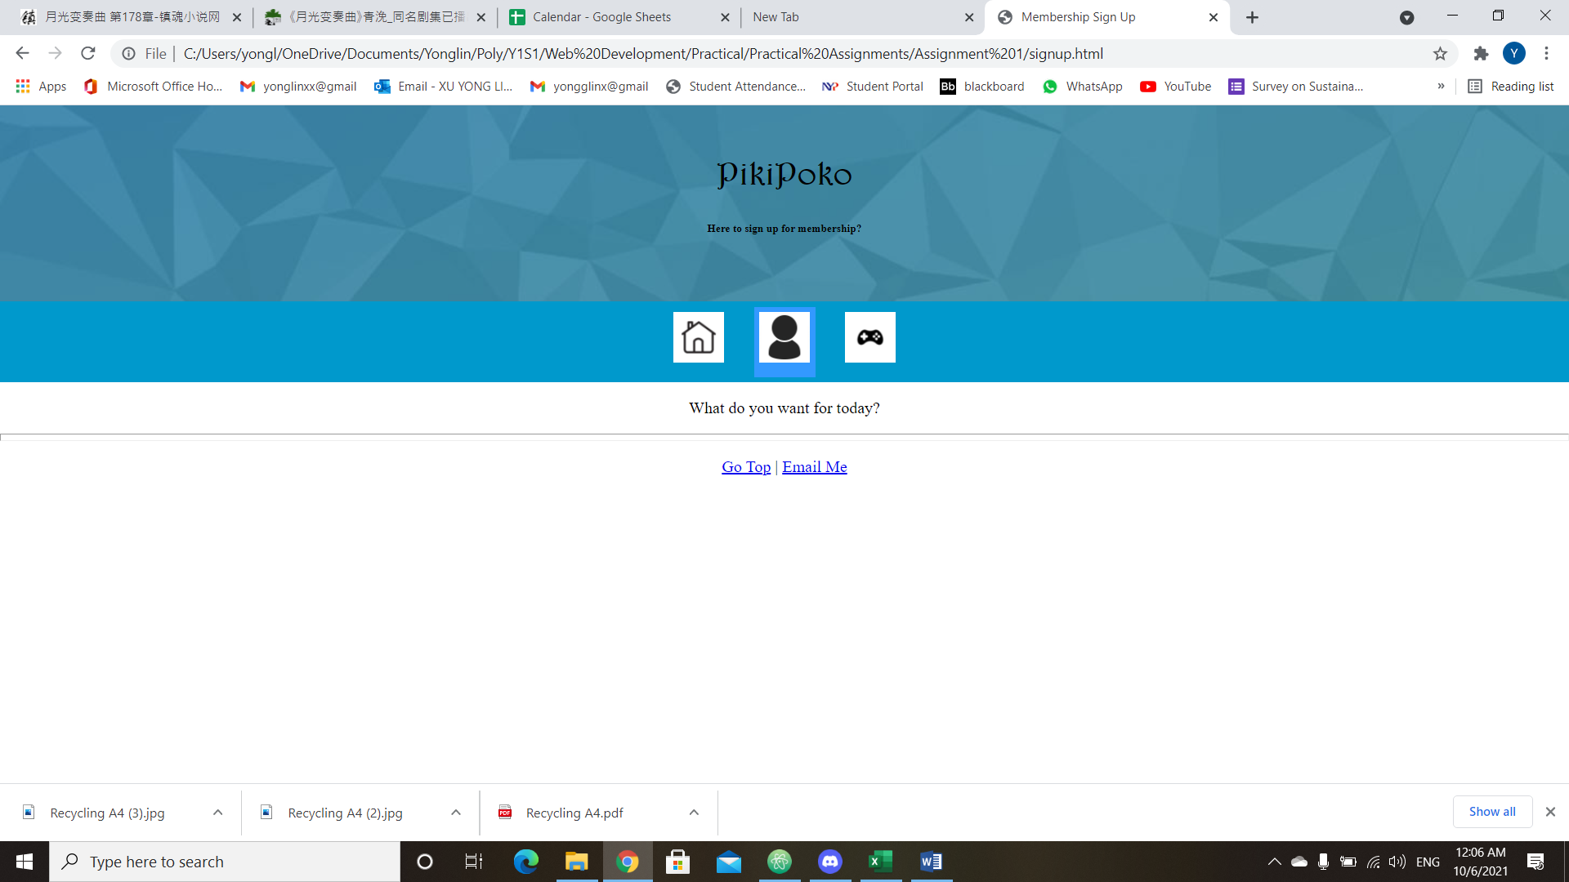

|  |  |  |
| --- | --- | --- |
| Membership page | Sign up for membership to get access to more pages / purchase notes and items |  |
|  | Ask for name, age, school, subjects that the student take etc |  |



**Resources page:**

Have yet to create a html folder for this

|  |  |  |
| --- | --- | --- |
| Resources page | Recommend users subject/module notes put up by users |  |
|  | Can purchase the items at a cheap price (in order to promote sharing of resources)   * Price range : $ 0.50 - $ 2.50 (so that it is affordable to students) |  |
|  | Search for stationary products, links to Ecommerce websites such as shopee/lazada for that particular product |  |
|  | Can add desired stationary/subject notes(from a particular blogger) into wishlist |  |
|  | Timetable  Calendar of events – exams/assignment submission reminder  To-do list for the week/day  Expenditure tracker (to promote saving from young) |  |

**Games:**

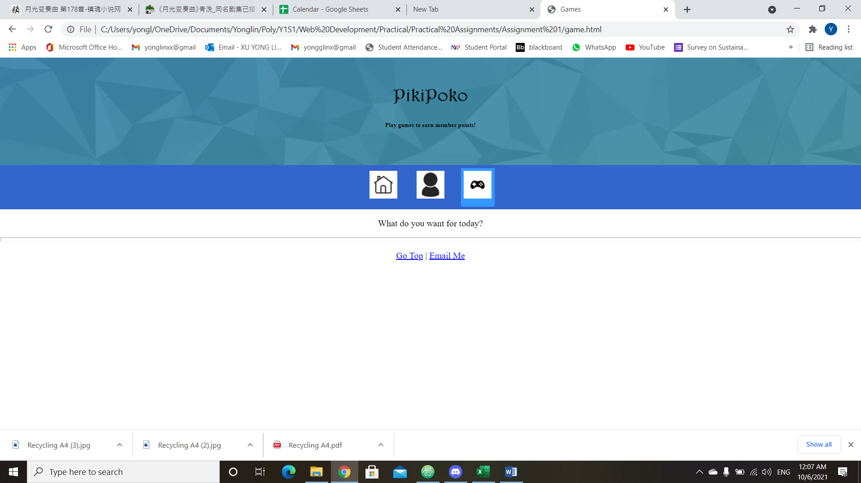

|  |  |  |
| --- | --- | --- |
| Games page / interactive page | Spin the wheel   * Users input the things they want to do for today * Spin the wheel to let it decide on what to do first (if the user is unsure of what to do at the moment) * (?)Will have a sticky note attached to the side of the screen so that users can refer to it :D |  |
|  | Another game (which I haven’t think of) |  |
| Discussion forum | * Something like Reddit, but in this forum, it is more general (eg a page for all students to ask for JavaScript questions, page to discuss this current political issue) |  |